The Los Angeles Times
Tuesday Morning, April 8, 1952

Flying Saucers ‘Explained’ by Men of New Research University Here

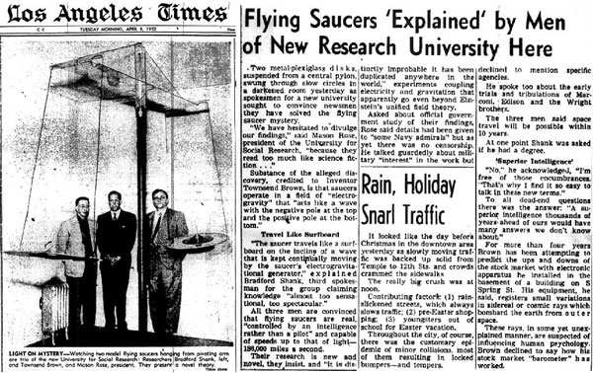

Two metal-plexiglass disks suspended from a central pylon swung through slow circles in a darkened room yesterday as spokesmen for a new university sought to convince newsmen they have solved the flying saucer mystery.

"We have hesitated to divulge our findings," said Mason Rose, president of the University for Social Research, "because they read too much like science fiction..."

Substance of the alleged discovery, credited to Inventor Townsend Brown, is that saucers operate in a field of "electro-gravity" that "acts like a wave with the negative pole at the top and the positive pole at the bottom."

--------------------------------------------------------------------
Travel Like Surfboard

"The saucer travels like a surfboard on the incline of a wave that is kept continually moving by the saucer's electro-gravitational generator," explained Bradford Shank, third spokesman for the group claiming knowledge "almost too sensational, too spectacular."

All three men are convinced that flying saucers are real, "controlled by an intelligence rather than a pilot" and capable of speeds up to that of light - 186,000 miles a second.

Their research is new and novel, they insist, and "it is distinctly improbable it has been duplicated anywhere in the world."

Experiments coupling electricity and gravitation that apparently go even beyond Einstein's unified field theory.

Asked about official government study of their findings, Rose said details had been given to "some Navy admirals" but as yet there was no censorship. He talked guardedly about military "interest" in the work but declined to mention specific agencies.

He spoke too about the early trials and tribulations of Marconi, Edison and the Wright brothers.The three men said space travel will be possible within 10 years.

At one point Shank was asked if he had a degree.

--------------------------------------------------------------------
"Superior Intelligence"

"No," he acknowledged, "I'm free of those encumbrances. That's why I find it so easy to talk in these new terms." To all deadend questions there was the answer, "A superior intelligence thousands of years ahead of ours would have many answers we don't know about."

For more than four years Brown has been attempting to predict the ups and downs of the stock market with electronic apparatus he installed in the basement of a building on S. Spring Street. His equipment, he said, registers small variations in sidereal or cosmic rays which bombard the earth from outer space.

These rays, in some yet unexplainedmanner, are suspected of influencing human psychology. Brown declined to say how his stock market "barometer" has worked.

