**Memo from U.S. President John F. Kennedy**

**12 November 1963**

This memo written by the former president just prior to his assassination in Dallas, Texas, requests a sharing of information with the Soviet Union on the unknown UFOs held on file by the CIA and USA.

ORIGINAL

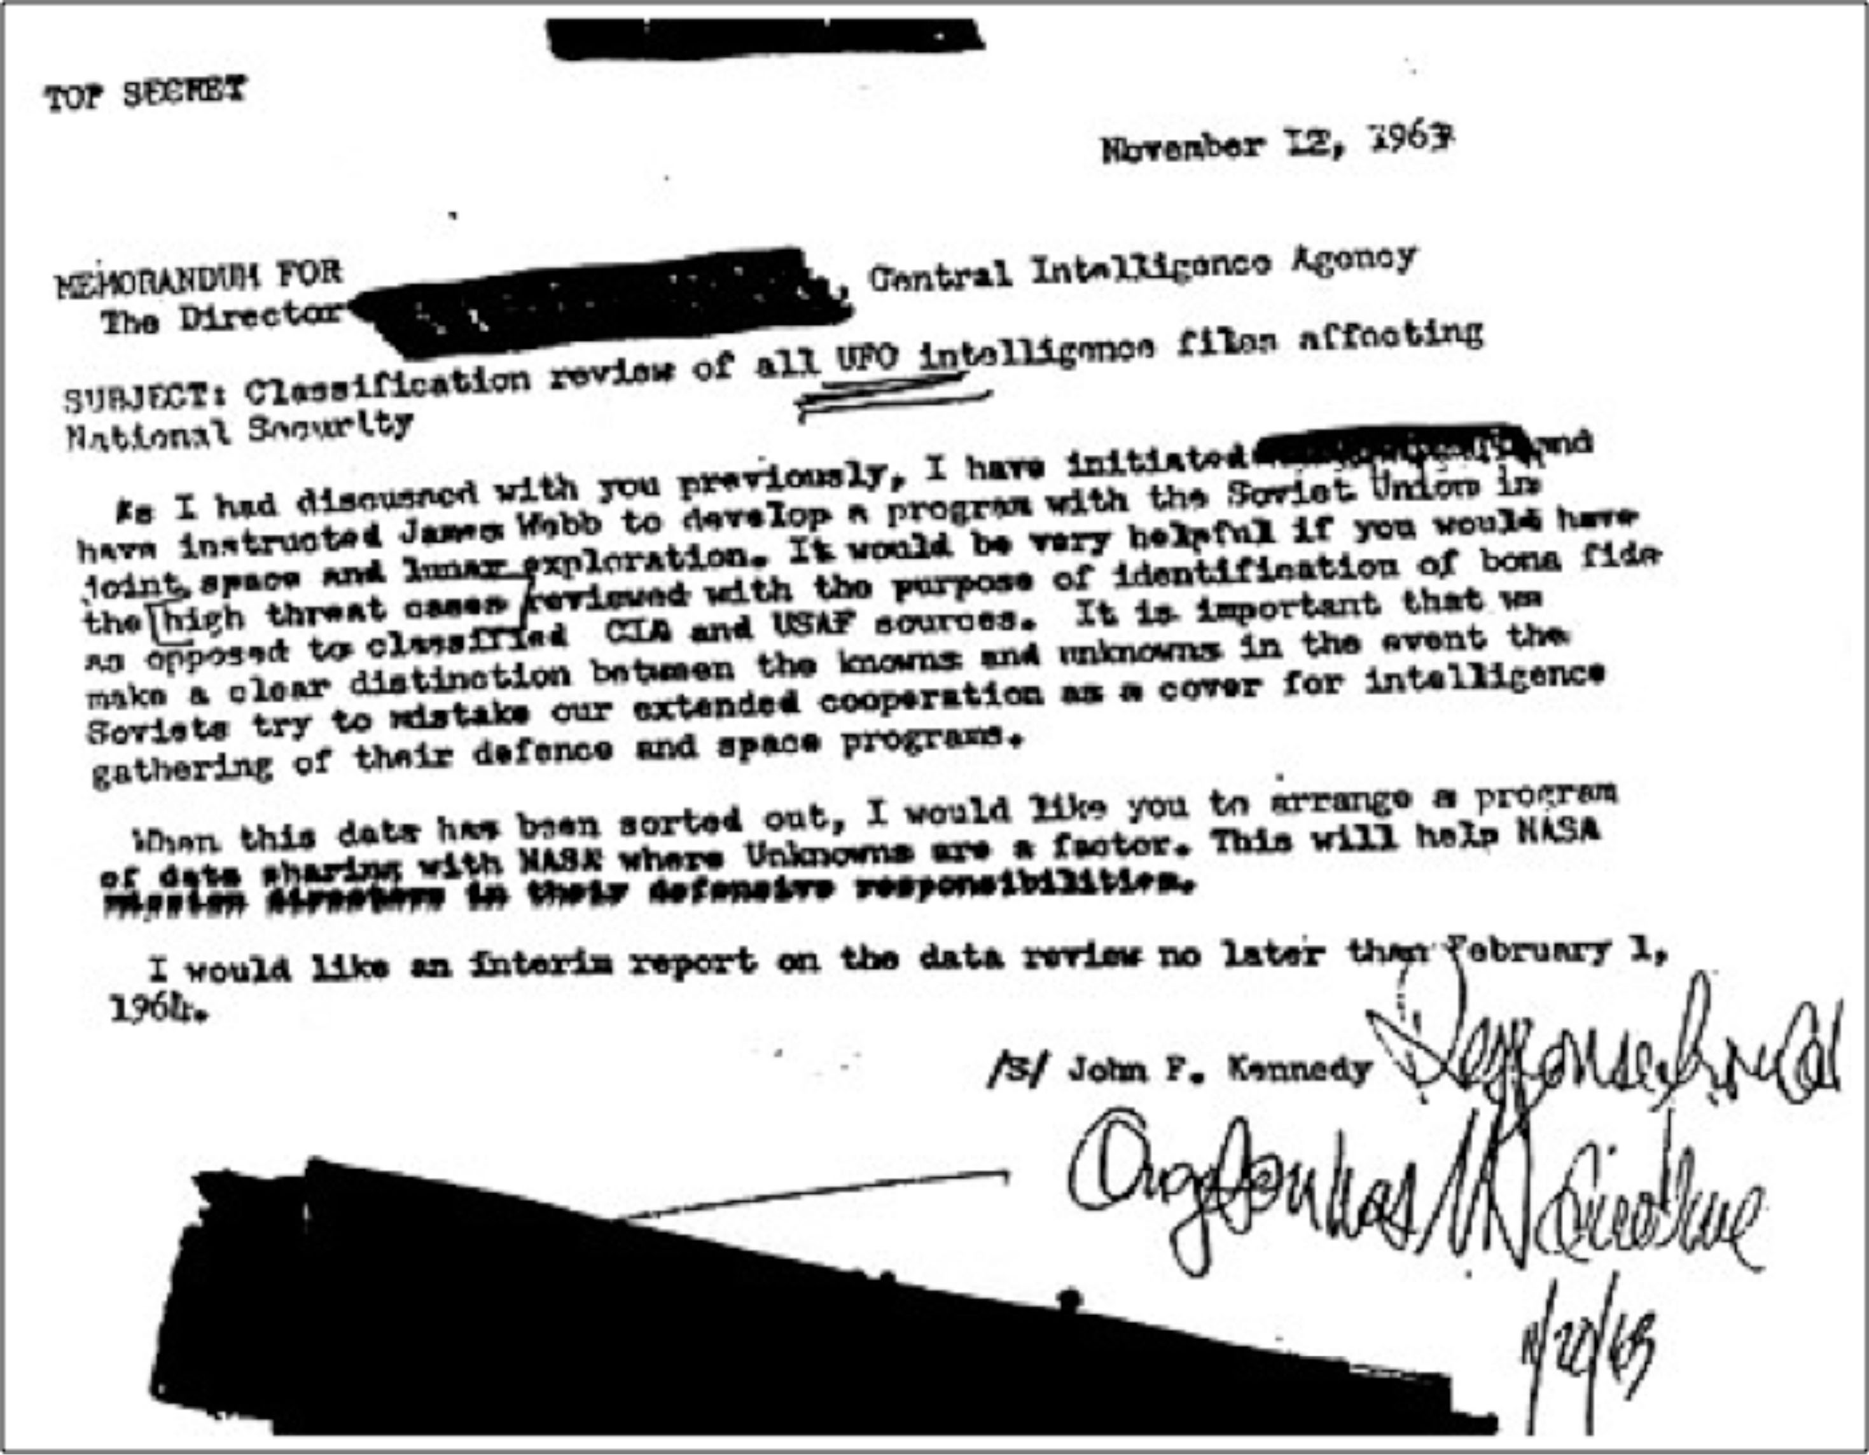

DIGITALLY ENHANCED VERSION



TEXT VERSION

TOP SECRET

November 12, 1963

MEMORANDUM FOR

The Director [blacked out], Central Intelligence Agency

SUBJECT: Classification review of all UFO intelligence files affecting National Security.

As I had discussed with you previously, I have initiated [unintelliigible] and have instructed James Webb to develop a program with the Soviet Union in joint space and lunar exploration. It would be very helpful if you would have the high threat cases reviewed with the purpose of identification of bona fide as opposed to classified CIA and USAF sources. It is important that we make a clear distinction between the knowns and unknowns in the event the Soviets try to mistake our extended cooperation as a cover for intelligence gathering of their defence and space programs.

When this date has been sorted out, I would like you to arrange a program of data sharing with NASA where Unknowns are a factor. This will help NASA mission directors in their defensive responsibilities.

I would like an interim report on the data review no later than February 1, 1964.

/S/ John F. Kennedy.