‘Flying Saucer’ is Found in New Mexico
Army Gives No Details of Mystery

Walla Walla Union-Bulletin, Tuesday morning, 8 July 1947, page 1.

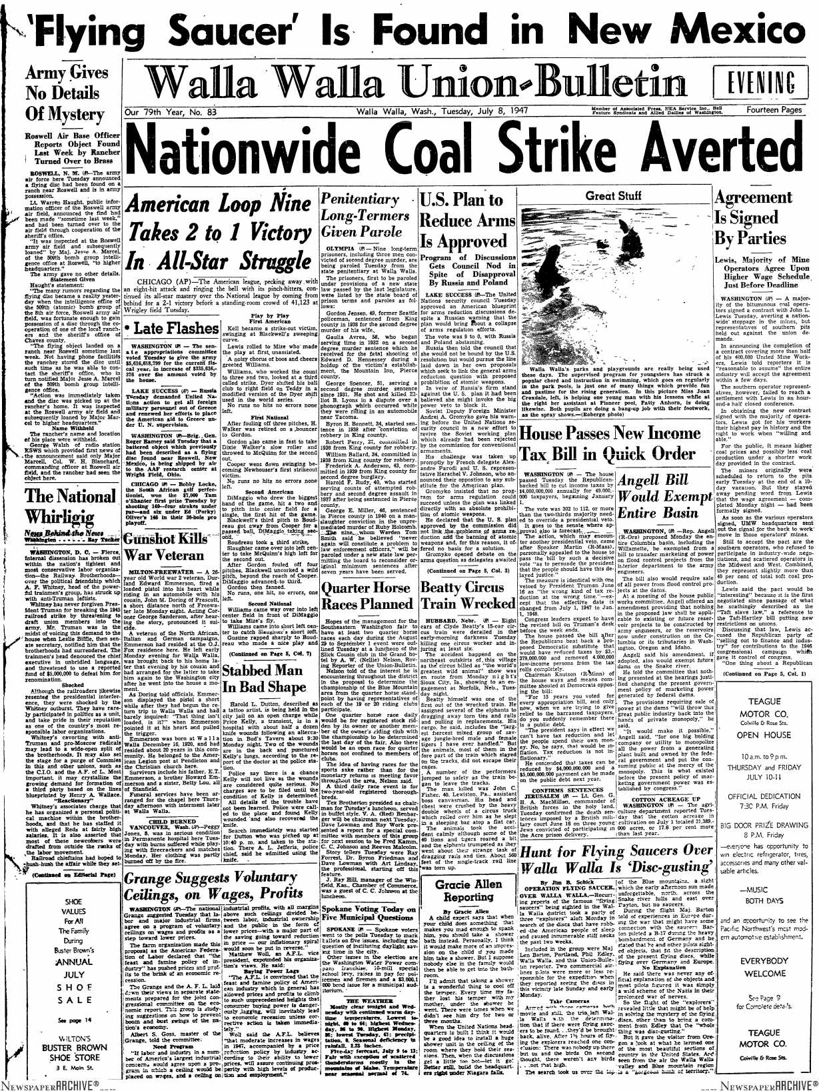
------------------------------------------------------------------------------------------------------

Roswell Air Base Officer Reports Object Found Last Week by Rancher Turned Over to Brass

ROSWELL, N.M.— The army air force here Tuesday announced a flying disc had been found on a ranch near Roswell and is in army possession.

Lt. Warren Haught, public information officer of the Roswell army air field, announced the find had been made “sometime last week” and had been turned over to the air field through cooperation of the sheriff’s office.

“It was inspected at the Roswell army air field and subsequently loaned” by Maj. Jesse A. Marcel, at the 509th bomb group intelligence office at Roswell, “to higher headquarters.”

The army gave no other details.

Statement Given

Haught’s statement:

“The many rumours regarding the flying disc became a reality yesterday when the intelligence office of the 509th (atomic) bomb group of the 8th air force, Roswell army air field, was fortunate enough to gain possession of a disc through the cooperation of one of the local ranchers and the sheriff’s office of Chaves county.

The flying object landed on a ranch near Roswell sometime last week. Not having phone facilities the rancher stored the disc until such time as he was able to contact the sheriff’s office, who in turn notified Major Jesse A. Marcel of the 509th bomb group intelligence office.

Action was immediately taken and the disc was picked up at the rancher’s home. It was inspected at the Roswell army air field and subsequently loaned by Major Marcel to higher headquarters.”

Name Withheld

This rancher’s name and location of his place were withheld.

George Walsh of radio station KSWS which provided first news of the announcement said only Major Marcell, Col. W.H. Blanchard, commanding officer at Roswell air field, and the rancher had seen the object here.

