U.S. Army to Examine a “Flying Disk”

The Times (London, U.K.), Tuesday 8 July 1947

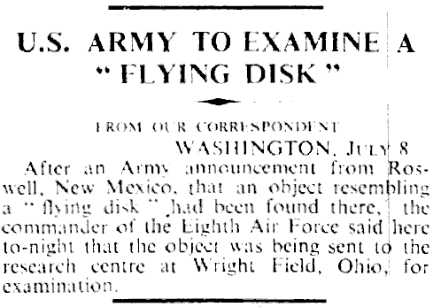

FROM OUR CORRESPONDENT
WASHINGTON, July 8

After an Army announcement from Roswell, New Mexico, that an object resembling a "flying disk" had been found there, the commander of the Eighth Air Force said here to-night that the object was being sent to the research centre at Wright Field, Ohio, for examination.

