Reward Offered for Capture of “Flying Saucer”

The Advertiser (Adelaide, Australia), Wednesday 9 July 1947

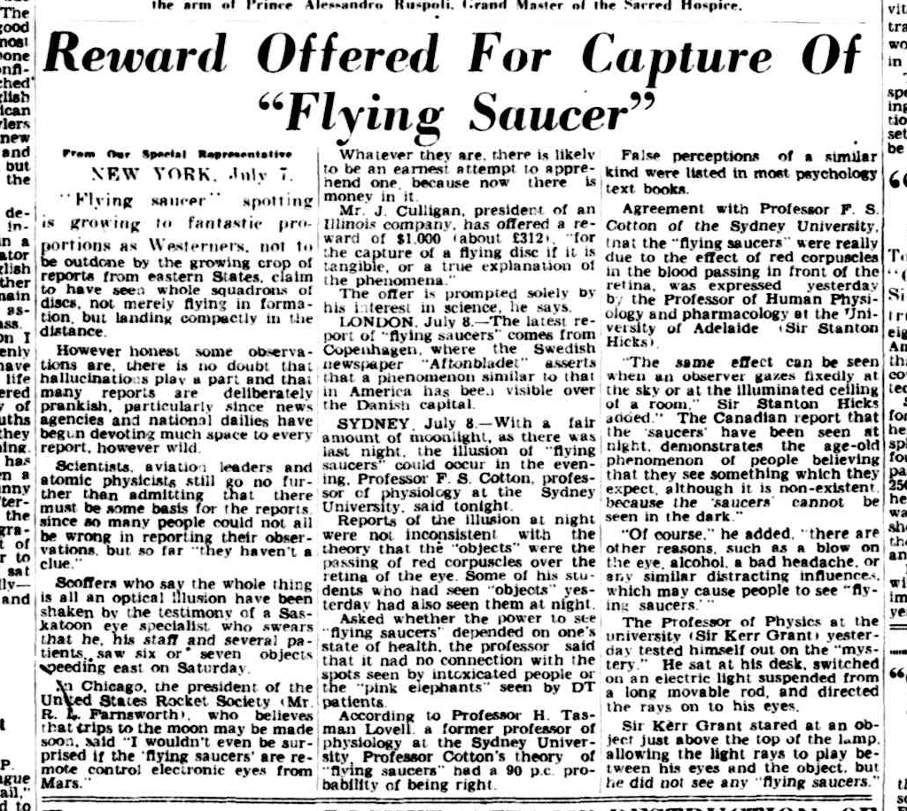

From Our Special Representative
NEW YORK, July 7.

“Flying saucer” spotting is growing to fantastic proportions as Westerners, not to be outdone by the growing crop of reports from eastern States, claim to have seen whole squadrons of discs, not merely flying in formation, but landing compactly in the distance.

However honest some observations are, there is no doubt that hallucinations play a part and that many reports are deliberately prankish, particularly since news agencies and national dailies have begun devoting much space to every report, however wild.

Scientists, aviation leaders and atomic physicists still go no further than admitting that there must be come basis for the reports, since so many people could not all be wrong in reporting their observations, but so far “they haven’t a clue.”

Scoffers who say the whole thing is all an optical illusion have been shaken by the testimony of a Saskatoon eye specialist, who swears that he, his staff and several patients, saw six or seven objects speeding east on Saturday.

In Chicago, the president of the United States Rocket Society (Mr. R. L. Farnsworth), who believes that trips to the moon may be made soon, said “I wouldn’t even be surprised if the ‘flying saucers’ are remote control electronic eyes from Mars.”

Whatever they are, there is likely to be an earnest attempt to apprehend one, because now there is money in it.

Mr. J. Culligan, president of an Illinois company, has offered a reward of $1,000 (about £312), “for the capture of a flying disc if it is tangible, or a true explanation of the phenomena.”

The offer is prompted solely by his interest in science, he says.

LONDON. July 8—The latest report of “flying saucers” comes from Copenhagen, where the Swedish newspaper “Aftonbladet” asserts that a phenomenon similar to that in America has been visible over the Danish capital.

SYDNEY. July 8—With a fair amount of moonlight, as there was last night, the illusion of “flying saucers” could occur in the evening. Professor F. S. Cotton, professor of physiology at the Sydney University, said tonight.

Reports of the illusion at night were not inconsistent with the theory that the “objects” were the passing of red corpuscles over the retina of the eye. Some of his students who had seen “objects” yesterday had also seen them at night.

Asked whether the power to see “flying saucers” depended on one’s state of health, the professor said that it had no connection with the spots seen by intoxicated people or the “pink elephants” seen by DT patients.

According to Professor H. Tasman Lovell, a former professor of physiology at the Sydney University, Professor Cotton’s theory of “flying saucers” had a 90 p.c. probability of being right.

False perceptions of a similar kind were listed in most psychology text books.

Agreement with Professor F. S. Cotton of the Sydney University, that the “flying saucers” were really due to the effect of red corpuscles in the blood passing in front of the retina, was expressed yesterday by the Professor of Human Physiology and pharmacology at the University of Adelaide (Sir Stanton Hicks).

“The same effect can be seen when an observer gazes fixedly at the sky or at the illuminated ceiling of a room,” Sir Stanton Hicks added. “The Canadian report that the ‘saucers’ have been seen at night, demonstrates the age-old phenomenon of people believing that they see something which they expect, although it is non-existent because the ‘saucers’ cannot be seen in the dark.”

“Of course,” he added, “there are other reasons, such as a blow on the eye, alcohol, a bad headache, or any similar distracting influences, which may cause people to see ‘flying saucers’.”

The Professor of Physics at the university (Sir Kerr Grant) yesterday tested himself out on the “mystery.” He sat at his desk, switched on an electric light suspended from a long movable rod, and directed the rays on to his eyes.

Sir Kerr Grant stared at an object just above the top of the lamp, allowing the light rays to play between his eyes and the object, but he did not see any “flying saucers.”

