Army Reveals it has Flying Disc
found on Ranch in New Mexico

Sacramento Bee, Tuesday 8 July 1947

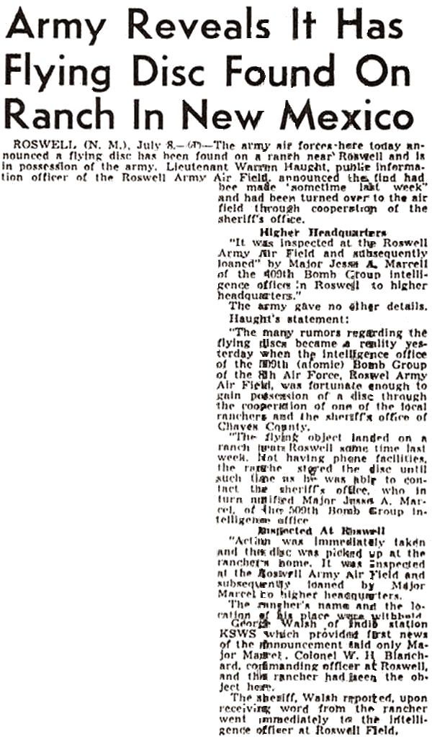

ROSWELL (N.M.). July 8. (AP) — The army air forces here today announced a flying disc has been found on a ranch near Roswell and is in possession of the army. Lieutenant Warren Haught [sic], public information officer of the Roswell Army Air Field, announced the find had been made "sometime last week" and had been turned over to the airfield through the cooperation of the sheriff's office.

Higher Headquarters

"It was inspected at the Roswell Army Air Field and subsequently loaned by Major Jesse A. Marcel of the 509th Bomb Group Intelligence office in Roswell to higher headquarters."

The army gave no other details. Haught's statement:

"The many rumors regarding the flying discs became a reality yesterday when the intelligence office of the 509th (atomic) Bomb Group of the 8th Air Force, Roswell Army Air Field, was fortunate enough to gain possession of a disc through the cooperation of one of the ranchers and the sheriff's office of Chaves county.

"The flying object landed on a ranch near Roswell sometime last week. Not having phone facilities, the rancher stored the disc until such time as he was able to contact the sheriff's office, who inturn notified Jesse A. Marcel, of the 509th Bomb Group intelligence office."

Inspected at Roswell

"Action was immediately taken and the disc was picked up at the rancher's home. It was inspected at the Roswell Army Air Field, and subsequently loaned by Major Jesse Marcel to higher headquarters."

The rancher's name and the location of his place was withheld.

George Walsh of the radio station KSWS which provided first news of the announcement said only Major Marcel, Colonel W. H. Blanchard, commanding officer at Roswell, and the rancher had seen the object here.

The sheriff, Walsh reported, upon receiving word from the rancher went immediately to the intelligence officer at Roswell Field.

