Disc Mystery Is 'Solved' For Three Hours Until Roswell Find Collapses

Albuquerque Journal, Wednesday morning, 9 July 1947, page 1.

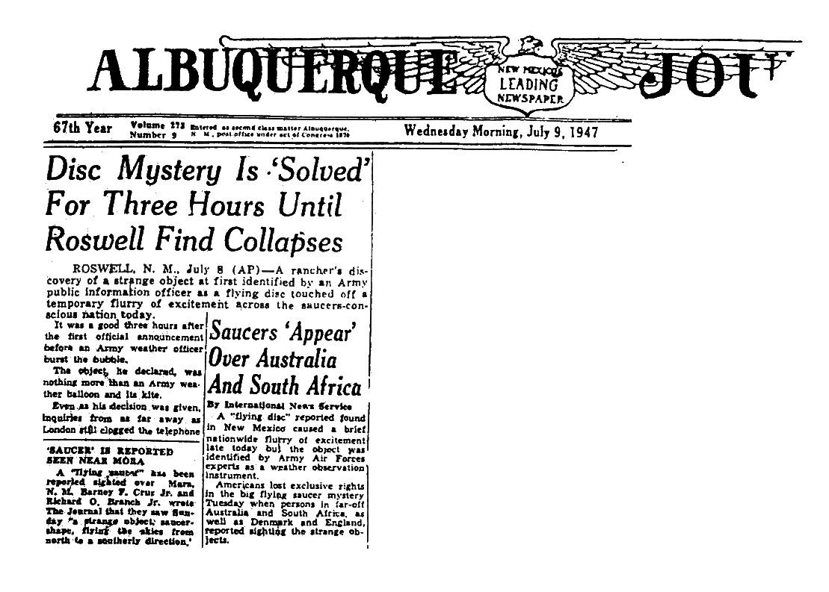
------------------------------------------------------------------------------------------------------

ROSWELL, N.M. July 8 (AP) -- A rancher's discovery of a strange object at first identified by an Army public information officer as a flying disc touched off a temporary flurry of excitement across the saucers-conscious nation today.

It was a good three hours after the first official announcement before an Army weather officer burst the bubble.

The object, he declared, was nothing more than an Army weather balloon and its kite.

Even as his decision was given, inquiries from as far away as London still clogged the telephone circuits into this medium-sized eastern New Mexico town. Sheriff George Wilcox' line was the busiest.

"The London Daily Mail called, and I've just finished talking to New York, he told a reporter late in the afternoon. "I also had calls from two other London papers -- I forgot to get their names - and there were more from every big newspaper in the United States, the radio networks and still others."

The identification, later discredited, of the mystery object, picked up in a pasture near the center of the state, came from Lieut. Walter Haut, public information officer at the Roswell Army Air Field.

"The many rumors regarding the flying disc became a reality yesterday when the intelligence office of the 309th (atomic) bomb group *** was fortunate enough to gain possession of the disc," Haut had said in a statement. The object was flown to Fort Worth Army base in an Army B-29 and the final identification was announced there.

Sheriff Wilcox and W.W. Brazel, about 50, made the find on the Foster ranch near Corona, 85 miles northwest of Roswell. Brazel, who has his own small ranch nearby, notified the sheriff's office yesterday and related he made the discovery some days before, Wilcox said.

The sheriff said he called Maj. Jesse A. Marcel of the 509th bomb group intelligence office at once and the officer accompanied Brazel back to the ranch to recover the object.

Wilcox said he did not see the object but was told by Brazel it was "about three feet across." The sheriff declined to elaborate. "I'm working with those fellows at the base," he said.

Army weather experts in Washington discounted any idea that weather targets might be the basis for the scores of reports of "flying discs."

Brig. Gen. Donald N. Yates, chief of the AAF weather service, said only a very few of them are used daily, at points where some specific project requires highly accurate wind information from extreme altitudes. Without field reports he would not hazard a guess on a precise number, he said.

